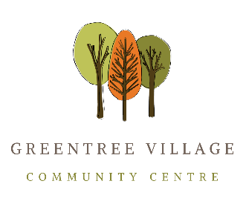

Policy on Promotion on GTVCCA Website
Policy #08
Date of Institution: 2020-09-27

Objective
This policy will make clear which programs and activities can be promoted on the GTVCCA Website. Programs and activities which are not in compliance with this policy can, and must, be approved on an individual basis by the Board for promotion on the website.

Definitions:
Greentree Village (GTV):
the 50 acre site is bounded by Wayburne Drive to the west, Woodsworth Street to the north, the Forest Lawn Cemetery to the east and Moscrop Street to the south. It is a mixture of single family homes and townhouses described by Burnaby City as a Suburban Multi-Family Area.
Green Tree Village Community Centre Association (GTVCCA):
is a non-profit society with a volunteer board of five directors. It was established in 1975 to oversee the management of GTVCC.
Green Tree Village Community Centre (GTVCC):
is a Community Centre for members of the GTVCCA located at 4295 Garden Grove Dr. Burnaby, B.C.

Description of Policy:
This policy applies to activities which are not organized by GTVCCCA and which are to be promoted anywhere on the GTVCCA website (https://greentreecommunitycenter.com/).
The activity promoted must:
- provide recreational or educational activities for the residents of GTV.
- be open to all residents of GTV.
- not be in violation of BC law, the constitution, bylaws and policies of the GTVCCA.
- not be political, religious, discriminatory or promote violence.
- be happening at the facilities of the GTVCC or Greentree Village Park.
- not place the GTVCCA in a liability situation.
- not promote or sell any goods or services other than what is directly related to the activity.
- not be primarily to support a charity.

Application:
This policy applies to all activities promoted on the GTVCCA Website.

Annual Review
This policy will be reviewed annually. All Staff and Members will have access to a copy.
Annual Review Date: | Reviewed By:

