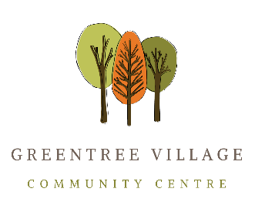

GTVCCA Reporting Disruptive Behaviour Procedures
Procedure #02 (of Policy #02)
Date of Institution: 2021-09

Procedure Objective:
The objective of this procedure is to ensure that should disruptive behaviour occur within the Greentree Village Community Centre that it is appropriately and promptly reported.

Reporting Procedures:
Incidents of disruptive behaviour should be reported as soon as possible after experiencing or witnessing an incident. This allows the incident to be investigated and addressed promptly.
- To report a disruptive behaviour either observed or experienced, contact the GTVCCA Staff or the Property Manager. If the reporting individual is not comfortable reporting to Staff or Property Manager then the GTVCCA Board of Directors may be contacted.
- The incident can be reported verbally or in writing. When submitting a written complaint, please use the GTVCCA Incident Report Form. When reporting verbally, the reporting contact, along with the person reporting the incident, will fill out the Incident Report Form together. (See sample in Appendix A).
- All witnesses to the incident will be encouraged to fill out an Incident Report Form.
- If the incident is a major incident of disruptive behaviour (i.e. harassment, bullying or discrimination) and none of the above avenues is possible, or is not adequately addressing the situation, contact WorkSafeBC prevention information line to report the incident. (1-888-621-7233)

Application:
This procedure applies to all persons working at the Centre and those using the facilities. It applies to interpersonal, written and electronic communications, such as email and other social media.

Annual Review:
This Policy will be reviewed annually. All Staff and Members will have access to a copy.
Annual Review Date: | Reviewed By:

